Osmotic Pressure (π)
Osmosis is the phenomenon of spontaneous flow of the solvent molecules through a semipermeable membrane from pure solvent to solution or from a dilute solution to concentrated solution. It was first observed by Abbe Nollet.
Some natural semipermeable membranes are animal bladder, cell membrane etc.
CU₂[Fe(CN)₆]is an artificial semipermeable membrane which does not work in non-aqueous solutions as it dissolves in them.
Osmosis may be

(i) Exosmosis
It is outward flow of water or solvent from a cell through semipermeable membrane.

(ii) Endosmosis
It is inward flow of water or solvent from a cell through a semipermeable membrane.
The hydrostatic pressure developed on the solution which just prevents the osmosis of pure solvent into the solution through a semipermeable membrane is called osmotic pressure.
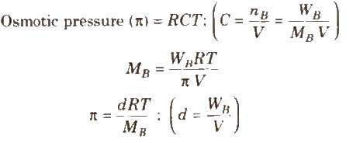
where, d = density, R = solution constant, T = temperature, M_{B} = molar mass of solute
Osmotic pressure can be determined by anyone of the method listed below
(i) Pfeffer‟s method
(ii) Berkeley and Hartley‟s method (very good method)
(iii) Morse and Frazer‟s method
On the basis of osmotic pressure, -the solution can be

(i) Hypertonic solution
A solution is called hypertonic if its osmotic pressure is higher than that of the solution from which it is separated by a semipermeable membrane.
When a plant cell is placed in a hypertonic solution, the fluid from the plant cell comes out and cell shrinks, this phenomenon is called plasmolysis.

(ii) Hypotonic solution
A solution is called hypotonic if its osmotic pressure is lower than that of the solution from which it is separated by a semipermeable membrane.

(iii) Isotonic solution
Two solutions are called isotonic if they exert the same osmotic pressure. These solutions have same molar concentration. 0.91% solution of pure NaCl is isotonic with human RBC‟s.
Two solutions are isotonic if they have the same molar concentration, e.g., if x % solution of X is isotonic with y % solution of Y, this means molar concentration of X = Molar concentration of Y
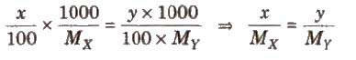
Osmotic pressure method is the best method for determining the molecular masses of polymers since observed value of any other colligative property is too small to be measured with reasonable accuracy.

Reverse osmosis
When the external pressure applied on the solution is more than osmotic pressure, the solvent flows from the solution to the pure solvent, I which is called reverse osmosis. Desalination of sea water is done by reverse Osmosis.

Abnormal Molecular Masses
In some cases, observed colligative properties deviate from their normal calculated values due to association or dissociation of molecules. As we know,
Colligative property ∝ 1 / M_{B}
lienee, higher and lower values of molar mass is observed in case of association and dissociation respectively, e.g., in benzene, acetic acid gets associated, so, its observed
molecular mass is 120. Similarly KCI undergoes dissociation in aqueous solution, so its observed molecular mass is 37.25.
These observed values are corrected by multiplying with van‟t Hoff factor (i).

van’t Hoff Factor (i)
It is the ratio of observed value of colligative property to the calculated value of colligative property.
i = observed value of colligative property / calculated value of colligative property
or i = normal molecular mass / observed molecular mass
or i = number of particles after association or dissociation / number of particles initially
So to correct the observed value of molar mass, van‟t Hoff factor (i) must be included in different expressions for colligative properties.
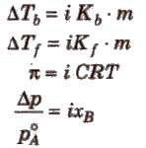

Degree of Dissociation (α) and van’t Hoff Factor (i)
(i) If one molecule of a substance gets dissociated into n particles or molecules and α is the degree of dissociation then
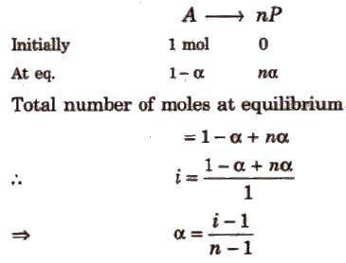

Degree of Association (α) and van’t Hoff Factor (i)
If n molecules of a substance A associate to form An and α is the degree of association then
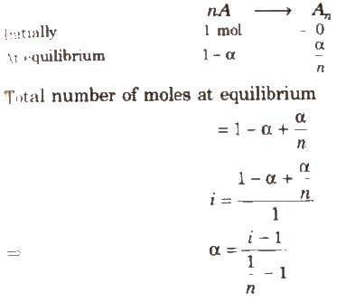
van‟t Hoff factor (i) > 1 for solutes undergoing dissociation and it is < 1 for solutes undergoing association.

